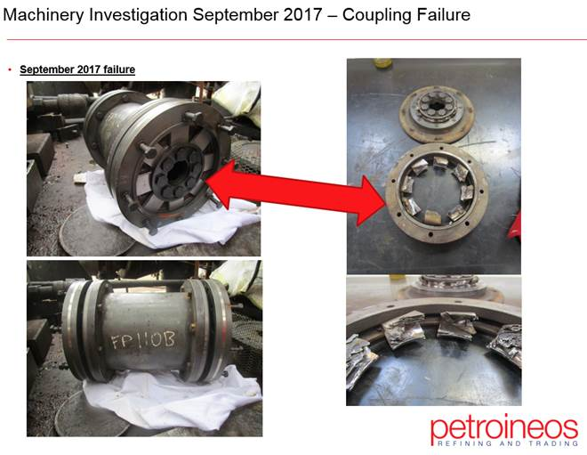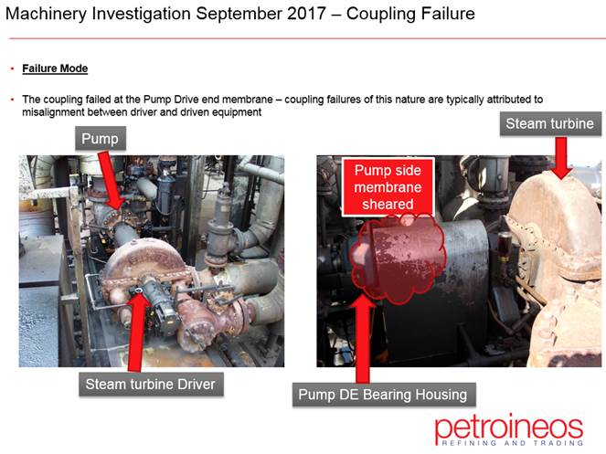

**BELOW OPPOSITION COUPLING WAS REPLACED BY THE THOMPSON COUPLING TCAE-4-R SUCCESSFULLY. THIS DEMONSTRATES THE DAMAGE AXIAL MOVEMENT OF STEAM TURBINE CAUSES BUT WHICH THE TCAE RANGE MINIMISES/ELIMINATES.**