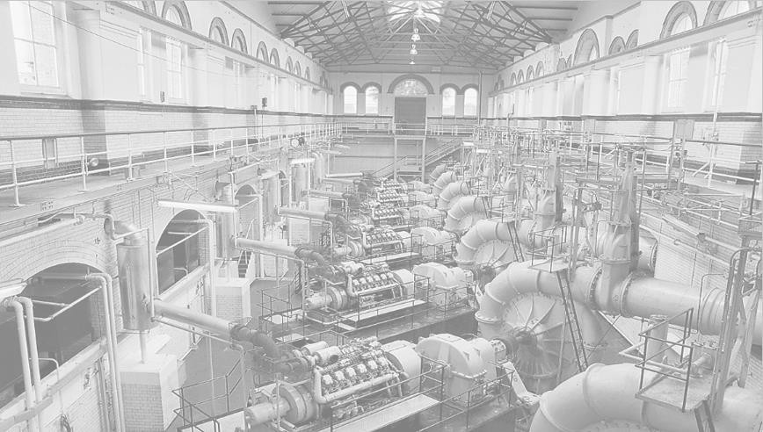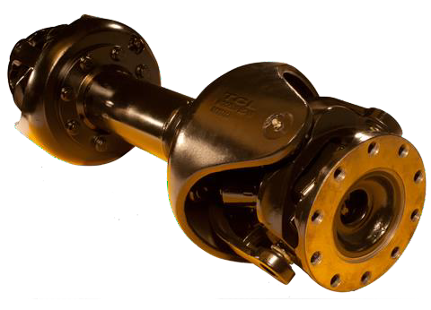

**TCVJ**

**INTERNATIONALLY PATENTED**

**OPERATES AT AMBIENT TEMPERATURE**

**REDUCES VIBRATION**

**WIDER DEFLECTION ANGLES**

**REDUCED ENERGY LOSSES**

**INCREASES POWER SAVINGS**

# BENEFITS

* Reduced friction, heat, wear, vibration and collateral damage
* Full load continuous operation at high output shaft angles
* Reduced energy losses
* Facilitates new designs with higher output shaft angles
* Runs at near to ambient temperature - durability

# CAPABILITIES

* A true constant velocity joint with no load bearing sliding surfaces that currently operates at angles to 20 degrees with special designs to 45 degrees.

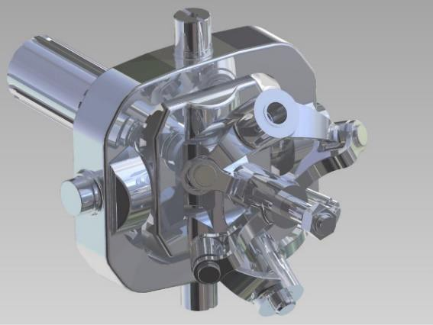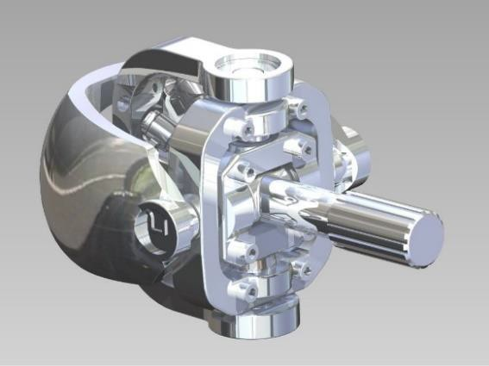

**Thompson Constant Velocity Joint (TCVJ)**

**Graphic of the Thompson Coupling showing the internationally patented, spherical 4-bar linkage**

**centring mechanism.**

|  |  |  |
| --- | --- | --- |
| R12-15 | R12-17 | R12-14 |

The Thompson Constant Velocity Joint (TCVJ) is a means of transmitting drive across an angled joint between driving and driven shafts with a true one-to-one ratio between the shafts.

The traditional problems associated with driving power around a corner of heat, vibration, loss of power and oscillating shaft speeds that have been inherent in universal joint technologies have all been addressed and overcome by the TCVJ.

Running at near to ambient temperatures, with no inherent vibration in its design, the TCVJ and its associated sliding shaft actually reduces vibrational inputs from gearboxes, reduction units and motors in a way that protects and prolongs the life of the system. Having no weight bearing sliding elements, the TCVJ has been born out of a re-understanding of the vectoring forces in play in rotating shafts and directional changes.

Made from forged and cast elements, the TCVJ design is scalable, meeting the differing needs of industry sectors - such as marine, industrial, transport and agriculture.

The TCVJ is the first of its type in the world, and is registered with the relevant patent authorities worldwide (USA, China, Europe, Japan, India, Russia, Israel, Brazil, Australia, Indonesia, South Korea, Singapore, Mexico, South Africa, Vietnam, Philippines, Canada)

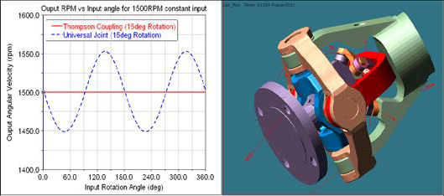

The graph above illustrates the difference in output motion of a universal joint (non-constant velocity) and a Thompson Coupling showing true constant velocity. The resultant non-constant velocity motion in traditional couplings produces shaft vibration and additional driveline forces causing increased wear and reliability issues for the power system.

**Targeted Markets and Installations**

**Marine -**

The TCVJ is currently installed as the drive coupling in Tug Boats and Yachts. In this situation the couplings protect and prolong the life span of both single engine diesel motor power sources and dual system diesel and electric power sources.

Other couplings have been installed into luxury yachts, sports fishing and high speed transport vessels.

**Industry -**

From electrical power generation to crushing mills and fabricators, opportunities exist where the transmission of drive power is required through either set angles; or, in circumstances where protection is necessary against changing situations. The ease of servicing, cool running and complete lack of vibration in the TCVJ product makes it the solution of first choice in every case.

**Transport -**

Already running in monorail infrastructure in the public domain, the TCVJ's have proved to be easy to manage and reliable in their work. The initial theoretical requirement of shifting the weight of the motor and gearbox combination has been achieved with ideal outcomes in smoothness of transmission and weight distribution.

**Agriculture -**

Many RFQ's and design proposals have been made for this sector in, predominately, the area of PTO's in heavy, mobile machinery. Harvesters, scarifiers, graders and irrigation and reticulation machinery have all proven to be rich in opportunities where power across changing angles and low maintenance requirements go hand in hand.

**Naming Convention and Specifications**

**Designation explanation:**

Example for model **TCVJ 2000-15**

Name Maximum Angle of deflection.

Torque (Nm)

**TCVJ MODELS**



The TCVJ2C15-version 6 model shown has a customized 10 stud flange as required by the customer.

TCVJ's can be supplied with either flange or shaft input and outputs.



Ready for dispatch; TCVJ 2000-15 joints with cardan shaft style spline shafts completing the coupling. They are being used in Mono Rail Trains.



These TCVJs are used to power a luxury yacht and tugboat allowing the marine architects a choice of engine positions.

With the engine horizontal, this single joint afforded control over the angle required for the propeller shaft, vibration free.

|  |  |  |  |  |
| --- | --- | --- | --- | --- |
| **PARAMETERS** | **UNITS** | **TCVJ 50** | **TCVJ 500** | **TCVJ 2000** |
|  |  |  |  |  |
| **NOMINAL DESIGN TORQUE** | **Nm** | **50** | **500** | **2,000** |
| **MAXIMUM TORQUE** | **Nm** | **200** | **1200** | **7,700** |
| **MAXIMUM DESIGN SPEED** | **RPM** | **3,000** | **3,000** | **2,500** |
| **FULL ARTICULATION ANGLE** | **degrees◦** | **30** | **15** | **15** |
| **L10 BEARING LIFE (1)** | **years** | **As per customer requirements** | | |
| **MAXIMUM SERVICE TEMPERATURE** | **◦C** | **120** | **120** | **120** |
| **COUPLING EFFECIENCY (2)** | **%** | **> 99.95** | **> 99.95** | **> 99.95** |
| **MAX. SWING DIAMETER** | **mm** | **75** | **193** | **260** |
| **OVERALL LENGTH** | **mm** | **68** | **169** | **225** |
| **WEIGHT** | **kg** | **1** | **11** | **22** |
| **ROTATIONAL MOMENT OF INERTIA** | **kgm2** | **0.0011** | **0.036** | **0.172** |
| **SPLINED SHAFT LENGTH** | **mm** | **As per customer requirements** | | |
| **MATING FLANGE CONNECTIONS** |  | **As per customer requirements to ISO specifications** | | |
|  |  |  |  |  |
| **PARAMETERS** | **UNITS** | **TCVJ 5000** | **TCVJ 8000** |  |
|  |  |  |  |  |
| **NOMINAL DESIGN TORQUE** | **Nm** | **5,000** | **6,350 (3)** |  |
| **MAXIMUM TORQUE** | **Nm** | **13,600** | **20,000** |  |
| **MAXIMUM DESIGN SPEED** | **RPM** | **2,000** | **1,600** |  |
| **FULL ARTICULATION ANGLE** | **degrees◦** | **15** | **± 10** |  |
| **L10 BEARING LIFE (1)** | **years** |  |  |  |
| **MAXIMUM SERVICE TEMPERATURE** | **◦C** | **120** | **120** |  |
| **COUPLING EFFECIENCY (2)** | **%** | **> 99.95** | **> 99.95** |  |
| **MAX. SWING DIAMETER** | **mm** | **393** | **350** |  |
| **OVERALL LENGTH** | **mm** | **347** | **394** |  |
| **WEIGHT** | **kg** | **82.5** | **80.7** |  |
| **ROTATIONAL MOMENT OF INERTIA** | **kgm2** | **1.47** | **0.945** |  |
| **SPLINED SHAFT LENGTH** | **mm** | **As per customer requirements** | |  |
| **MATING FLANGE CONNECTIONS** |  | **As per customer requirements to ISO specifications** | |  |