TCAE-2-R PTO Hydraulics Application – Loadpro Australia - X60 Truck

We have recently supplied a TCAE-2-R coupling to Loadpro Australia for a PTO hydraulics application for the new X60 Off Highway Truck to be used in the mining industry in Indonesia. Using the Thompson Couplings range of couplings means
No Laser Alignment is required for PTO applications.

  - TCAE-2-R – PTO Hydraulics Application – Technical Specifications
Use: X60 Truck
Engine: Mercedes OM502 LA, 480 Kw @ 1800 RPM
Hydraulic Pump: K3VL
Maximum operating angle: 1 - 10 degrees total, without the requirement for laser alignment
TCAE-2-R: Technical Specifications TCAE-2-R Tech Specs

See a short video here Loadpro X60 PTO Hydraulics Application
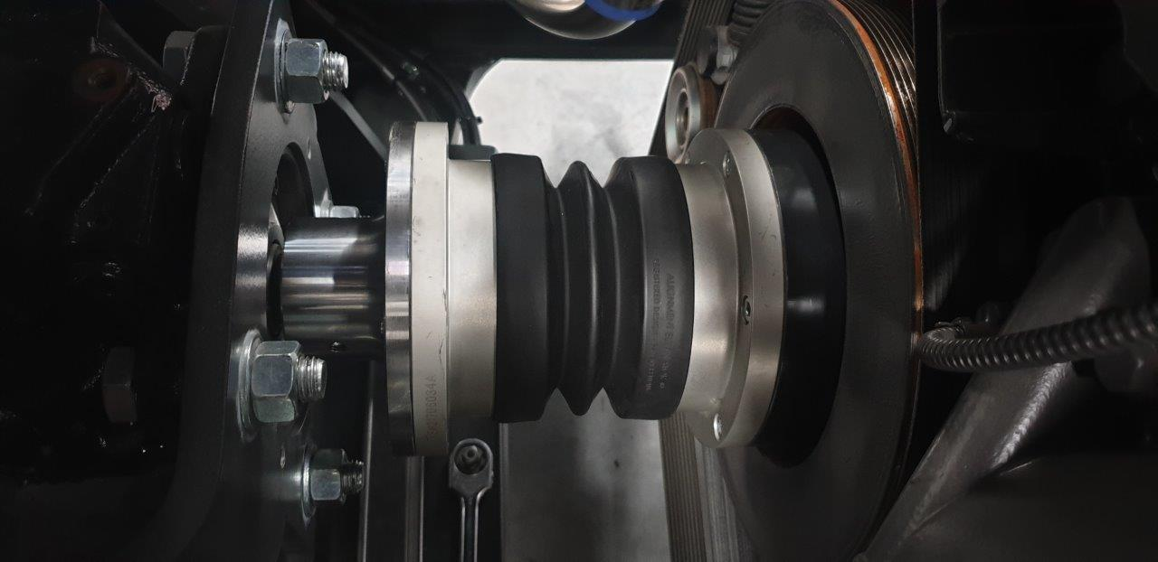

Jake Schliebs – Loadpro Australia “The driveline and coupling is working better then expected, with the customer preparing to order further units for the plant. “Loadpro designs and manufactures Off highway Trucks in Brisbane, Australia for the mining industry in the 65 Tonne weight class, Our X60 model required a high capacity hydraulic pump mounted directly from the engines harmonic balancer, After investigating various design solutions to couple the pump to the engine we became involved with Thompson Couplings, Their team were more than helpful during the design process and went above and beyond to cater to our requirements. Together we selected the Thompson Couplings TCAE-2-R for our application. We rubber mount our engine and fabricate our own chassis, so a coupling solution with high misalignment capabilities is the primary requirement, and the TCEA-2-R ticked all the boxes, with plenty of extra misalignment to spare. Since we selected the TCAE-2-R, we’ve been able to redesign the pump mount to a more cost effective method, since misalignment was no longer a problem for us”

